
COMSATS University Islamabad,
Abbottabad Campus

Project Proposal
(SCOPE DOCUMENT)
for
<PROJECT NAME>
Version 1.0
By
Student Name 1 CIIT/SP09-BCS-xxx/ATD
Student Name 2 CIIT/SP09-BCS-xxx/ATD

Supervisor
Supervisor Name

Bachelor of Science in Computer Science (20xx-20xx)
No. | Comment | Action
SCOPE DOCUMENT REVSION HISTORY

Supervisor Signature
Date:

Table of Contents
1. Introduction 4
2. Problem Statement 5
3. Problem Solution for Proposed System 5
4. Related System Analysis/Literature Review 5
5. Advantages/Benefits of Proposed System 5
6. Scope 6
7. Modules 6
7.1 Module 1: Module Name 6
7.2 Module 2: Module Name 6
8. System Limitations/Constraints 6
9. Software Process Methodology 6
10. Tools and Technologies 7
11. Project Stakeholders and Roles 7
12. Team Members Individual Tasks/Work Division 8
13. Data Gathering Approach 8
14. Concepts 8
15. Gantt chart 9
16. Mockups 10
17. Conclusion 11
18. References 11
19. Plaragism Report 11

Project Category: (Select all the major domains of proposed project)
- A-Desktop Application/Information System B-Web Application/Web Application based Information System C- Problem Solving and Artificial Intelligence D-Simulation and Modeling E- Smartphone Application F- Smartphone Game G- Networks H- Image ProcessingOther (specify category) ______________________

Abstract

Provide a one to two paragraph summary of your project. The abstract should give an idea of what your project is trying to achieve. Think of your abstract as a condensed version of your whole project. By reading it, the reader should understand the nature of your project. It should be comprehensive, and concise.

Introduction
Specify the purpose of this project proposal document along with description detailed background
of the system. (Usually in 10-12 sentences).

Problem Statement
What problem does your software solve? Why you are developing this system? Does the same
system already exists? If yes, how will a re-implementation aid your learning? What skills do you
expect to learn from this project? (Usually in 14-16 sentences)

Problem Solution for Proposed System
Briefly explain how your system solves the problems mentioned in the problem statement. (Usually in 14-16 sentences)

Related System Analysis/Literature Review
Write about the existing/similar systems related to your proposed project. At least three existing systems should be discussed.
Don’t use more than 4 sentences for explaining a single system/application.
Briefly explain the related system analysis which help to specify the contribution of the proposed project.
(Note: Research based projects may provide literature review instead of related system analysis.)

Table 1 Related System Analysis with proposed project solution
Application Name | Weakness | Proposed Project Solution
The name of related application(s). | Weaknesses may include limited features, low quality functionality and processes. | The way the proposed project mitigates the weaknesses.

Advantages/Benefits of Proposed System
Write down the advantages and benefits of the system you are developing. In other words, you have to mention here advantage of your proposed solution to the existing problem.
(Usually in 5-7 advantages)

Scope
Write down the scope of your project in a paragraph. Briefly define the main functionalities of the proposed project. Scope defines the boundaries and range of the proposed solution, that what would be the part of your project and what will be not. Write down in logical flow with consistency.
(Usually in 14-18sentences)

Modules
Write down the modules of the proposed project. Don’t forget to mention special/new features. Briefly explain your one module in 6 to 8 sentences.
(Note: Usually 5-6 Modules for 2 student’s projects and 8-9 modules for 3 student’s project)

Explanation of a Module: Module is a section of a program that performs a task. Programs consist of modules, each of which contains one or more routines. The term routine is synonymous with procedure, function, and subroutine.

Example:

Enterprise resource planning (ERP) software - is comprised of several large modules (for example, finance, supply chain and payroll, etc.), which may be implemented with little or no customization.

(Briefly explain each module with respect to major functionality in user context)

Module 1: Module Name

Module 2: Module Name

System Limitations/Constraints
Write down the limitations and constraints of the proposed project.
(Usually 2-4 constraints)

Software Process Methodology
Write down your software methodology/ software process that will be used for project development. .Also mention why you have chosen this methodology. (Usually 3-5 sentences)
- You can use Object Oriented Methodology, or Procedural methodology.
- Choice of methodology will affect choice of tools and technologies
- Choice of methodology will affect nature of design (SDS)
- Choice should be made depending on your expertise and your needs e.g. most simulation and device level software can only be programmed in procedural languages.

Tools and Technologies
Mention all the hardware/software tools and technologies with version number which will be used in implementation of the project. Write about the APIs, language(s), SDK(s) etc. which you will use for implementation.

Example:

Table 2Tools and Technologies for Proposed Project
Tools  And  Technologies | Tools | Version | Rationale
 | MS Visual Studio | 2015 | IDE
 | MS SQL Server | 2015 | DBMS
 | Adobe Photoshop | CSC 6 | Design Work
 | MS Word | 2015 | Documentation
 | MS Power Point | 2015 | Presentation
 | Pencil | 2.0.5 | Mockups Creation
 | Technology | Version | Rationale
 | C# | 6.0 | Programming language
 | SQL | 2013 | Query Language
 | Html | 5 | Web Development

Project Stakeholders and Roles
Write down the project stakeholders and their roles.

Table 3Project Stakeholders for Proposed Project
Project Sponsor | All web applications and desktop applications should have real client. Mention your project sponsor.  Default option will be: COMSATS University, Islamabad
Stakeholder | Mention your stake holders with their roles and responsibilities.  Default option will be:  - Students names  - Project Supervisor Name: Mr./Miss …  - Final Year Project Committee: Evaluation of project

Team Members Individual Tasks/Work Division
Table 4Team Member Work Division for Proposed Project
Student Name | Student Registration Number | Responsibility/ Modules
Student 1 Name | Student 1 Registration Number | Describe the work division of each  student along with modules  E.g.  Mr. Ali (Module1-Module3)  Augmented reality and Databases tasks.

Data Gathering Approach
Write down information and requirement gathering approaches for proposed project e.g. Interview, Questionnaire etc. (Usually 3-5 sentences)

Concepts
Mention the concepts that you will learn while doing the proposed project.
For example: Augmented Reality, Virtual Reality, Algorithms, API’’s Code injection, Closures, VI technique etc.
Not more than 4 sentences for one concept. (Usually 3-5 concepts are briefly mentioned)

Example:

Concept-1: Concept Name E.g. Augmented Reality (Briefly give the overview of concept with respect to your project)

Gantt chart
Create the Grant Chart and provide estimated start and end dates of all proposed modules/tasks for each team member. Also identify the dependencies (which tasks cannot be started/completed, until the dependent task is completed). Gantt chart can be created using MS Project.
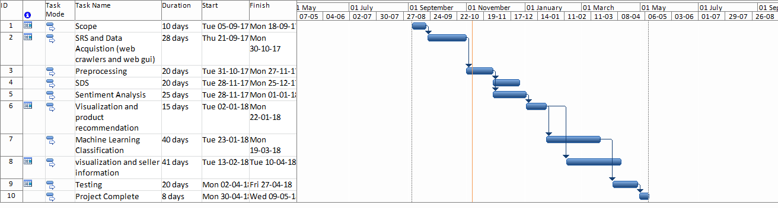
Figure 1Sample Gantt chart

Mockups
Insert minimum mockups (Usually 4-6 mockups) which show the major modules mentioned in the scope section of the document. Do not include mockups for Login, Signup, Forgot Password, Contact Us, About Us etc. If the project is a Web or a Smartphone Application, then include at-least three mockups from each part of the project. You can design mockup in any design tool for example pencil tool (https://pencil.evolus.vn/) or Balsamiq (https://balsamiq.com/)

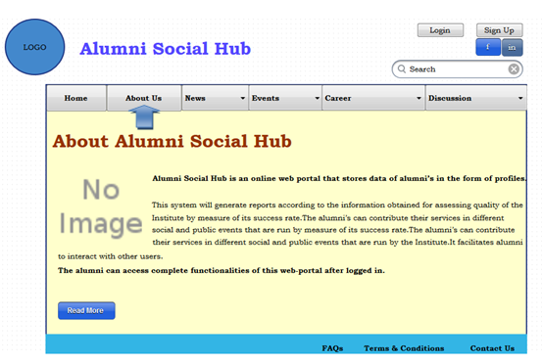

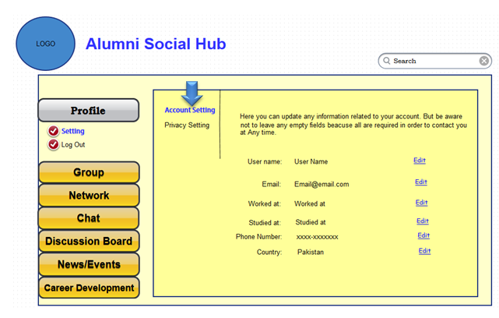

Conclusion
Conclude this document. (Usually 4-5 sentences)

References
Mention the books, research papers, web links etc.

Plagiarism Report
Attach the Plagiarism report of your project scope document from library staff of turnitin tool (http://turnitin.com

